A

Report

On

World Philosophy Day 2023

Session :2023-24

Department of Philosophy

Rabindra Mahavidyalaya,

champadanga, Hooghly

Theme: World Philosophy Day

Venue: Rabindra Mahavidyalaya

Department of Philosophy

Room no 71

Date:24th November 2023

Organizer: Department of Philosophy

Objectives:

- To understand and respond to major contemporary challenges by creating the intellectual conditions for change
- To give a clear understanding of various subjects
- Realizing the Value of philosophy
- To create or engage interest in a new area
- to make students understand the learning concepts and prepare them for the real world. Therefore, teachers have been incorporating different strategies to enhance the efficacy of the lecture methods
- For the development of thinking
- Stimulating intercultural dialogue
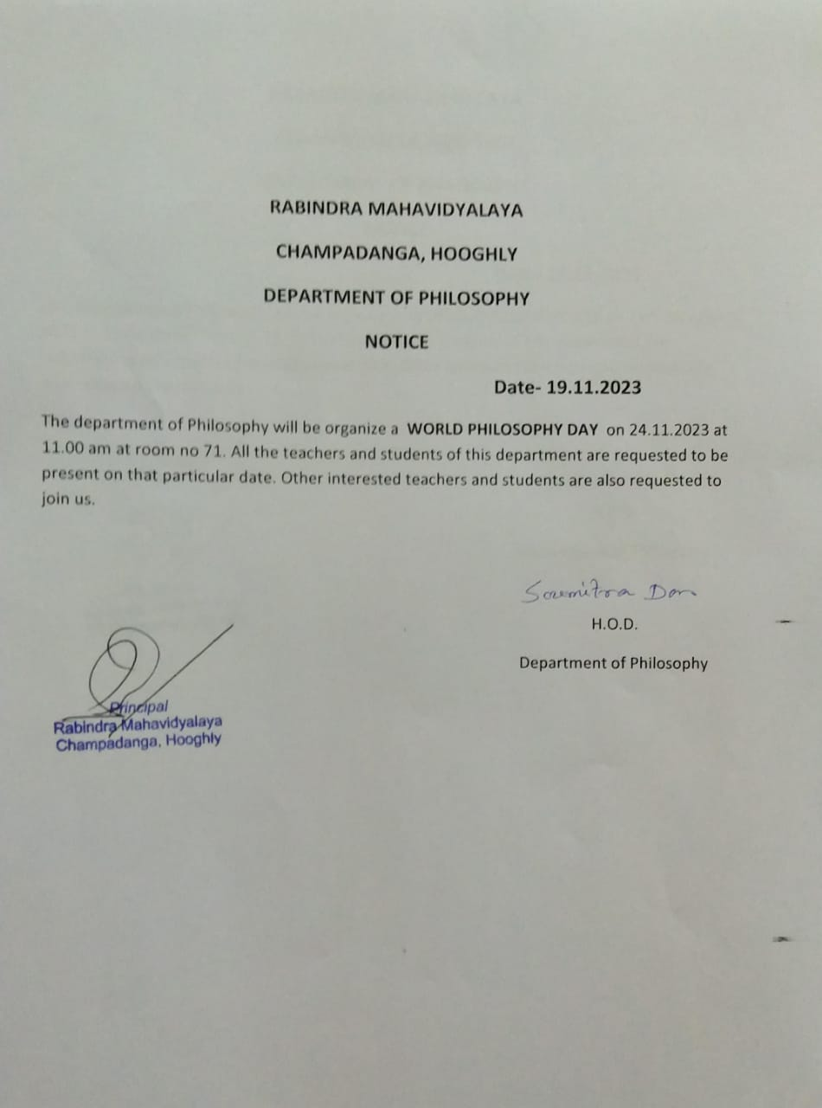

summary

On November 24th November, 2023, World Philosophy Day was celebrated in the Department of Philosophy. By celebrating World Philosophy Day each year, on the third Thursday of November, UNESCO underlines the enduring value of philosophy for the development of human thought, for each culture and for each individual.

First, Professor Soumitra Das head of the Department the lamp lighting in front of Radhakrishnan's portrait. In the portrait, flowers and garlands were given by prof. SuklaSaha and prof. SanchitaKheto. 4 teachers and 60 students were present in the event. Then the students performed an opening song. A short cultural program of half an hour with dance, song recital etc. After that begins the educational program.

A Special Lecture session was organized on this occasion. The topic was “Perception/Pratakhsya”. The speaker was prof. SuklaSaha, prof. of the Department of philosophy. Students like the lecture session very much. They learn a lot.
To promote understanding via explanations of particularly difficult concepts. To respond to student misconceptions or difficulties. To create or engage interest in a new area. To synthesize information across a range/variety of material.

Our participants: 103
Male:21
Female:82

Tentative programmed schedule
- Inaugural session: 11.30a.m. to 11.45a.m.
- Inaugural speech:11.45a.m. to 12 noon
- Other speech: 12noon to 12:30 p.m.
- Cultural programme: 12.30 p.m. to 1.00 p.m.
- Lunch break: 1.00 p.m. to 1:30 p.m.
- Special lecture: 1:30 p.m. to 3:30 p.m.

Feedback from students:
- 60% felt satisfactory
- 70 percent wished to occur the event more than once every year
- 100 percent students agreed this event helped to improve their logical performance
- Want more such philosophical topic, which is related to our daily life
- They want smart class room

